Linxin Liu

INFO 6205

April 7th 2021

Extra Assignment Report

I have created a snake method in the Priority queue class. I also created a boolean named floyd to decide whether the take method shall use snake method or not. Then, I update the Priority queue test cases to test the snake method and the new take method, and all test cases have passed. Here is the screenshot of that:

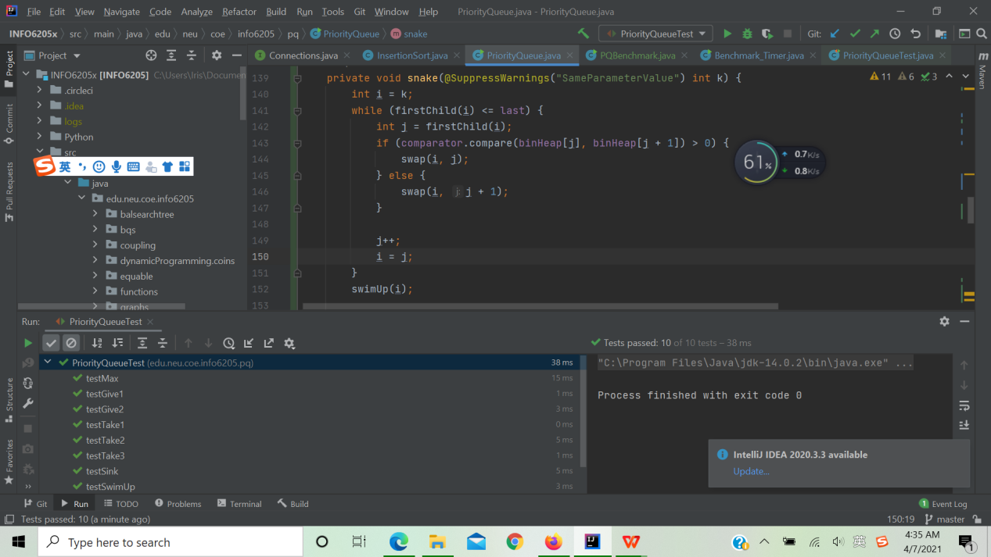

After running benchmark, I believe that Floyd’s method takes an element from a string type priority queue faster than taking an element from an int type priority queue. The image below is my running results:

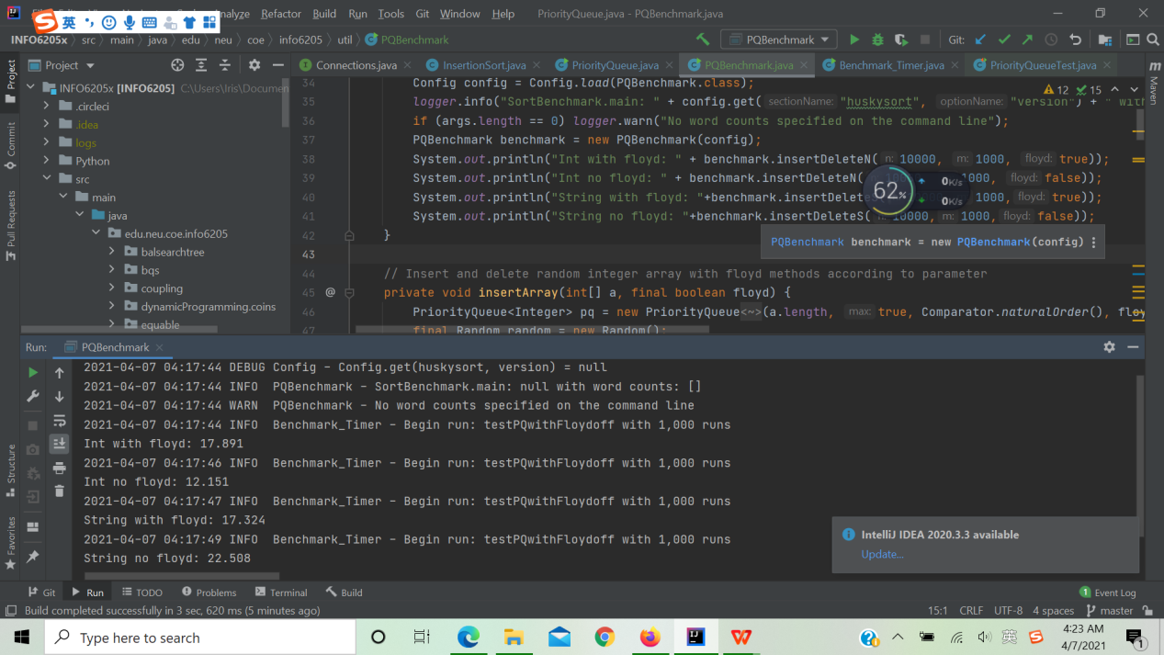

In order to make this more clearly for view, I made a bar chart to show the differences in nanoseconds between string type and int type priority queue used or not used Floyd’s method.